ASA LAB ( THY DAYUTH )

Topolgy
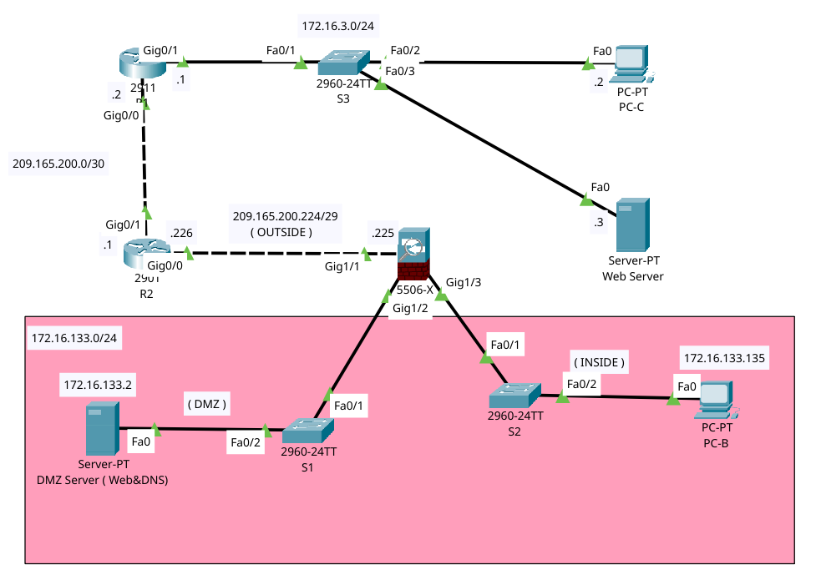

3. Basic Configuration
- Command 1: show interface ip brief
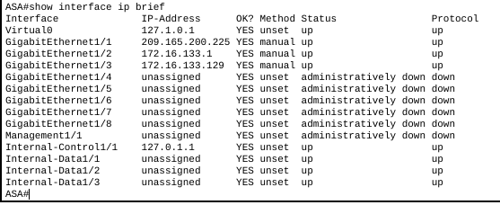

4. SSH Configuration
- Command: show run
ASA#show running-config
ASA Version 9.6(1)
!
hostname ASA
domain-name cisco.com
names
!
interface GigabitEthernet1/1
nameif outside
security-level 0
ip address 209.165.200.225 255.255.255.248
!
interface GigabitEthernet1/2
nameif dmz
security-level 50
ip address 172.16.133.1 255.255.255.128
!
interface GigabitEthernet1/3
nameif inside
security-level 100
ip address 172.16.133.129 255.255.255.128
!
interface GigabitEthernet1/4
no nameif
no security-level
no ip address
shutdown
!
interface GigabitEthernet1/5
no nameif
no security-level
no ip address
shutdown
!
interface GigabitEthernet1/6
no nameif
no security-level
no ip address
shutdown
!
interface GigabitEthernet1/7
no nameif
no security-level
no ip address
shutdown
!
interface GigabitEthernet1/8
no nameif
no security-level
no ip address
shutdown
!
interface Management1/1
management-only
no nameif
no security-level
no ip address
shutdown
!
object network DMZ_SERVER
host 172.16.133.2
nat (dmz,outside) static 209.165.200.227
object network INSIDE_NET
subnet 172.16.133.128 255.255.255.128
nat (inside,outside) dynamic interface
!
route outside 0.0.0.0 0.0.0.0 209.165.200.226 1
!
access-list OUTSIDE_IN extended permit tcp any object DMZ_SERVER eq www
access-list OUTSIDE_IN extended permit udp any object DMZ_SERVER eq domain
!
!
access-group OUTSIDE_IN in interface outside
aaa authentication ssh console LOCAL
!
username admin password 4IncP7vTjpaba2aF encrypted
!
class-map inspection_default
match default-inspection-traffic
!
policy-map type inspect dns preset_dns_map
parameters
message-length maximum 512
policy-map global_policy
class inspection_default
inspect dns preset_dns_map
inspect ftp
inspect icmp
inspect tftp
!
service-policy global_policy global
!
telnet timeout 5
ssh 172.16.133.128 255.255.255.128 inside
ssh timeout 5
!
dhcpd dns 172.16.133.2
!
dhcpd address 172.16.133.135-172.16.133.150 inside
!
!
!
!
ASA#
- Bonus Screenshot:
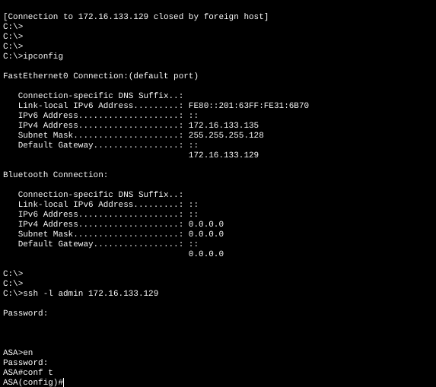

6. Routing
- Command: show route
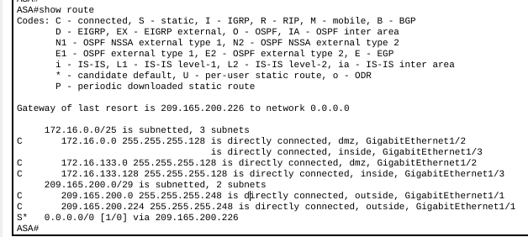

7 & 8. Dynamic & Static NAT
- Command: show run nat
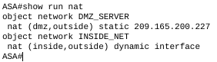

- Alternative Command: show nat
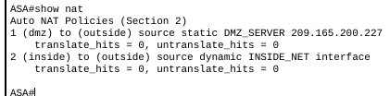

9. Access Control Lists (ACL)
To prove your firewall rules are created and applied to the correct interfaces:
- Command 1: show access-list
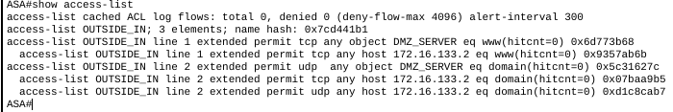

10. Final Verification
- Command 1: ping 172.16.133.129 (Proves inside connectivity)
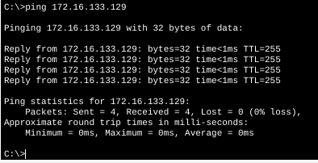

- Command 2: ping DMZ
